

**DBMS PROJECT**

**FREIGHT MANAGEMENT SYSTEM**

**Group Members:**

1. Bilal Ahmed Khan (20k-0183)
2. Hameez Ahmed Siddiqui (20k-0242)
3. **Introduction:**

Our Freight management System is a tool that helps ports efficiently handle logistics, inventory and accounts of a port. It offers features such as inventory management, accounts details, payment/order gateways to streamline the shipping process. This software can help ports save time and money by reducing errors and improving the speed and accuracy of their logistics operations by enabling them to make data-driven decisions about their transportation strategy.

1. **Technology Used:**
   1. **Front End:**
      1. HTML
      2. CSS
      3. Bootstrap
   2. **Back End:**
      1. Php
   3. **Database:**
      1. Mysql
2. **System Design:**

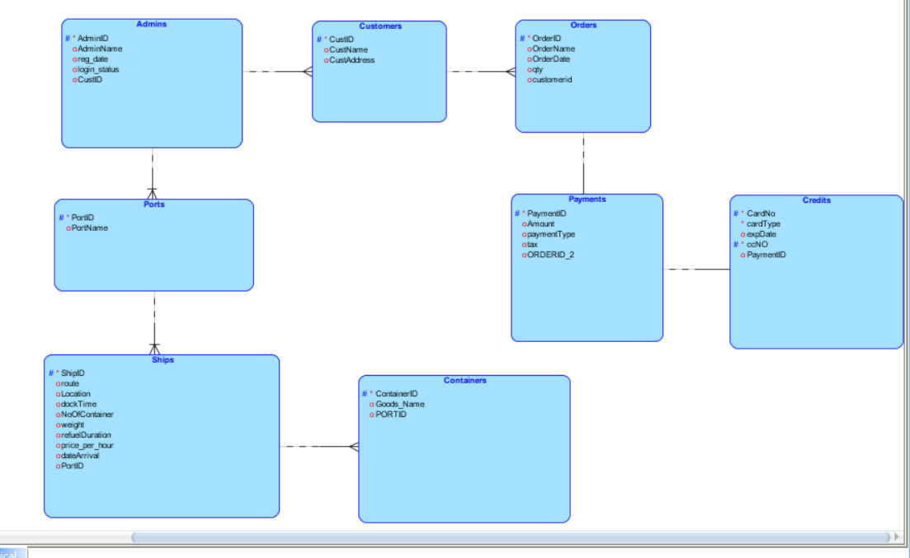

Original schema diagram included inside the project files

1. **Normalization:** 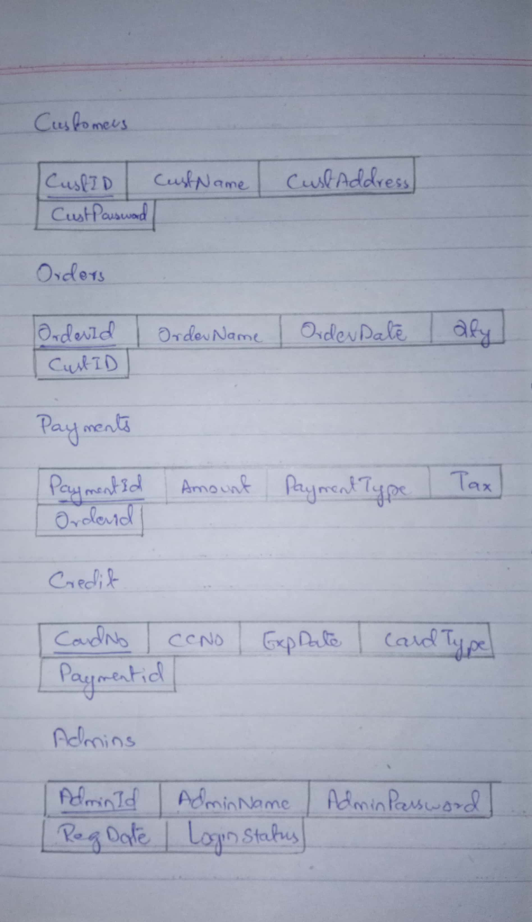

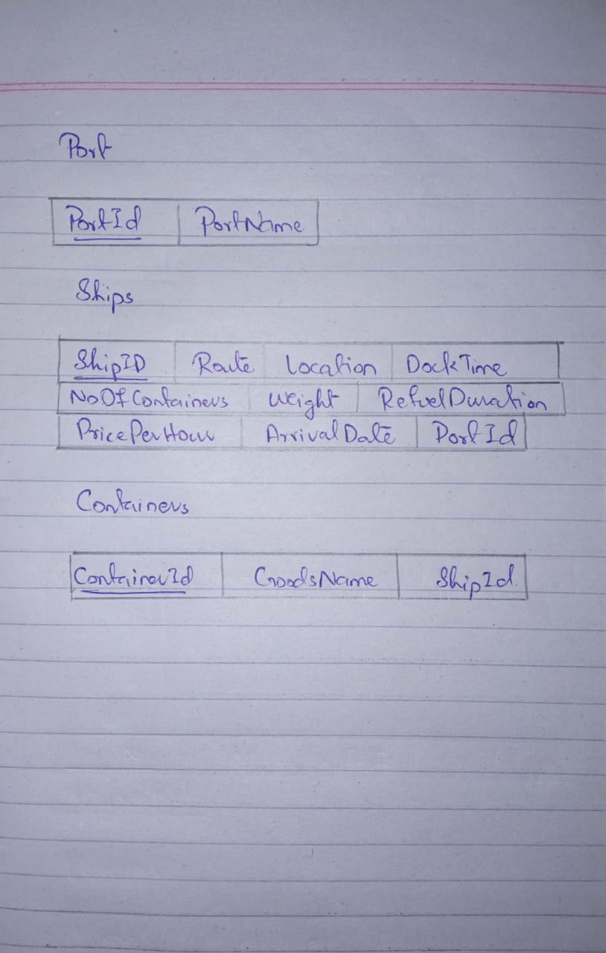

1. **Procedure, Functions (the implemented ones):**
   1. **Create, Read, Update Delete Functionality for the following entities**
      1. Payments

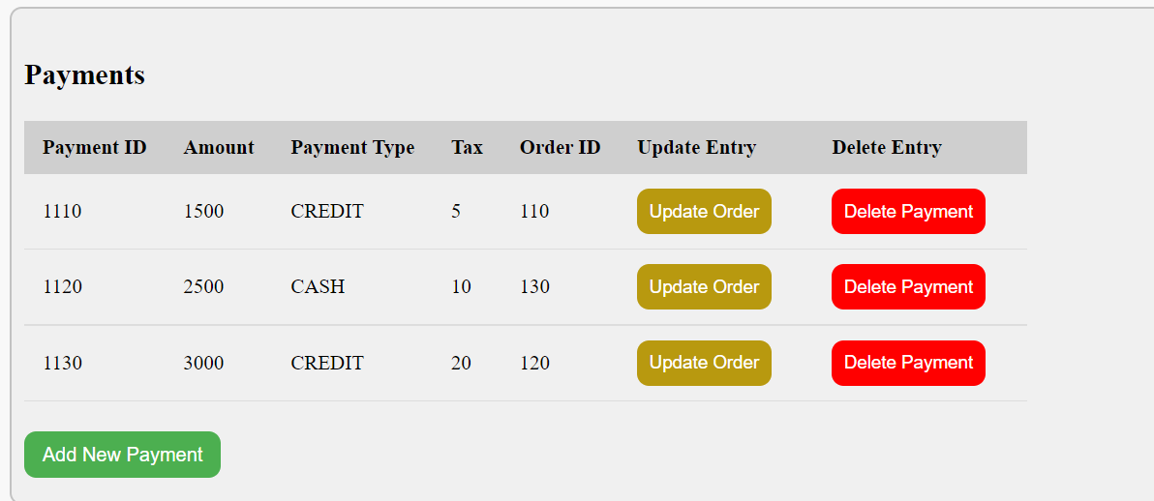

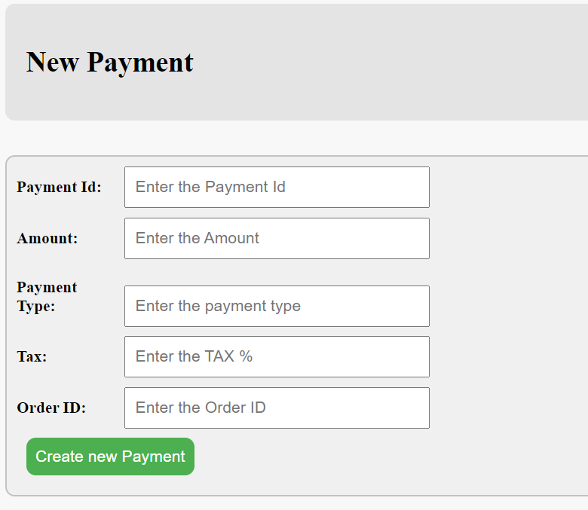

* + 1. Orders

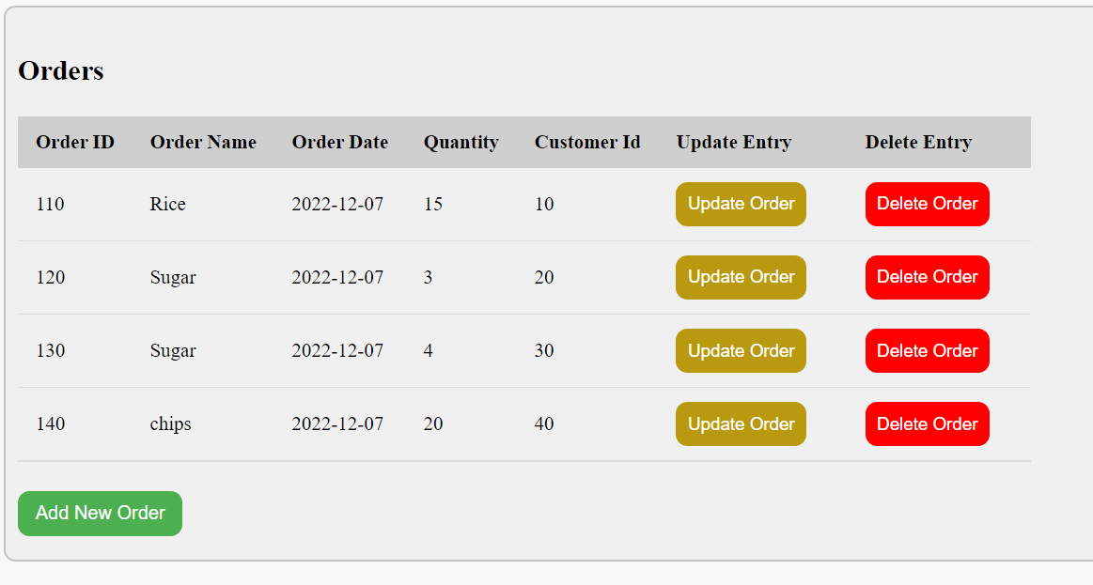

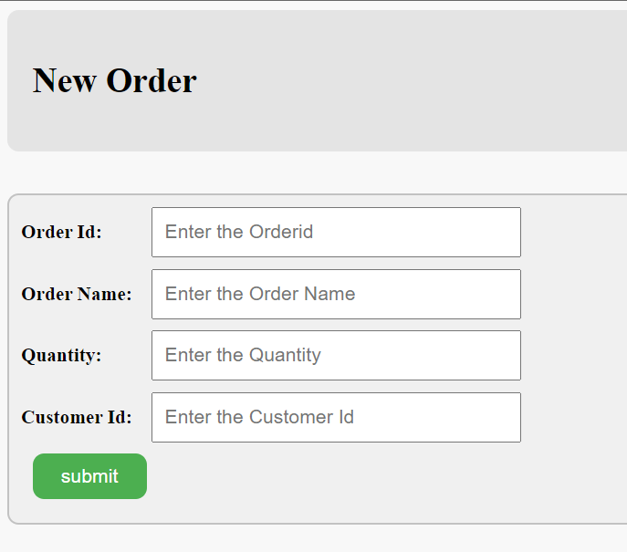

* + 1. Ships

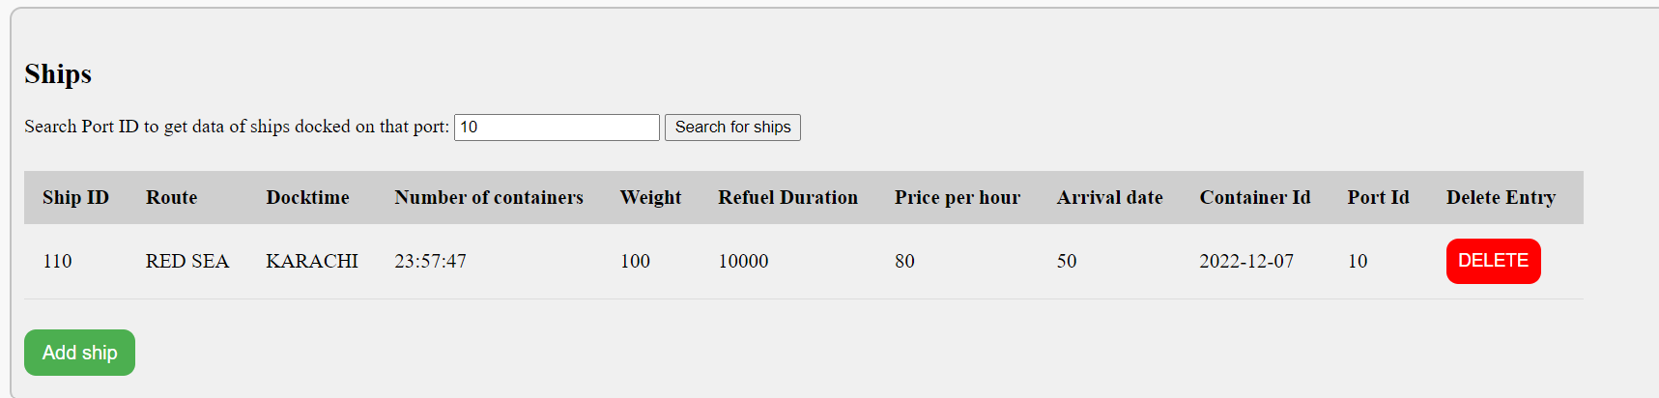

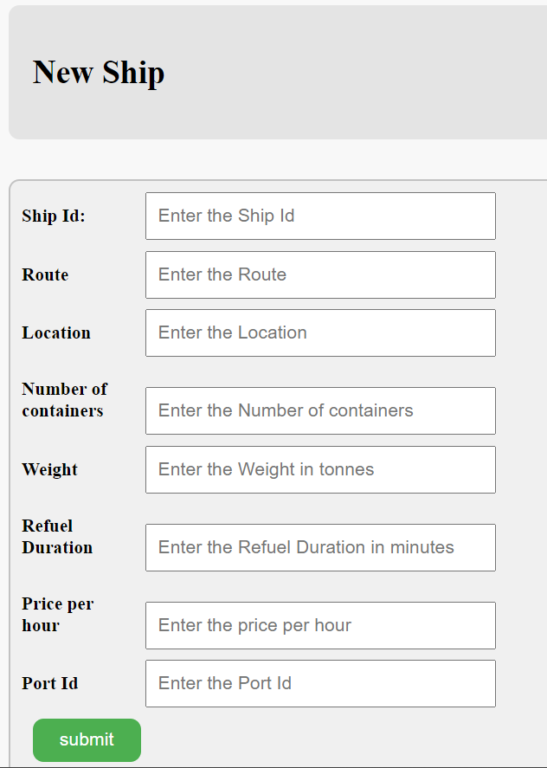

* + 1. Ports

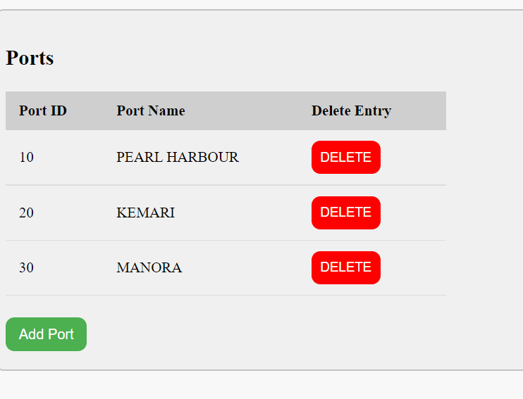

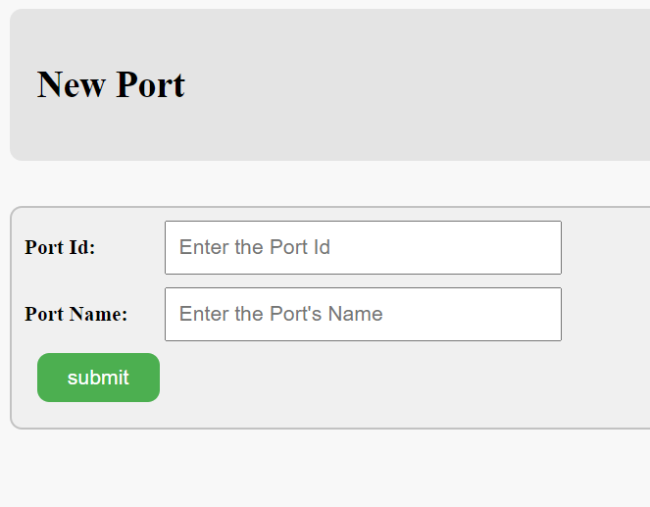

* + 1. Containers

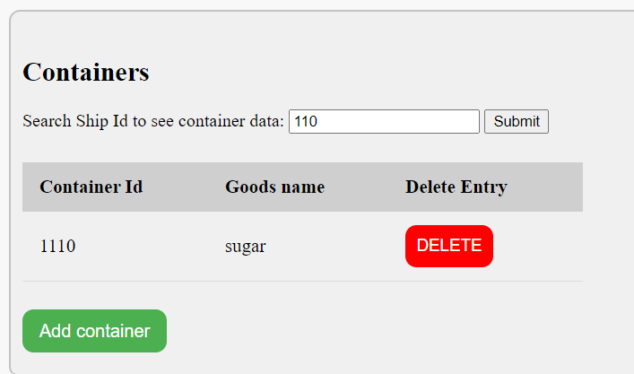

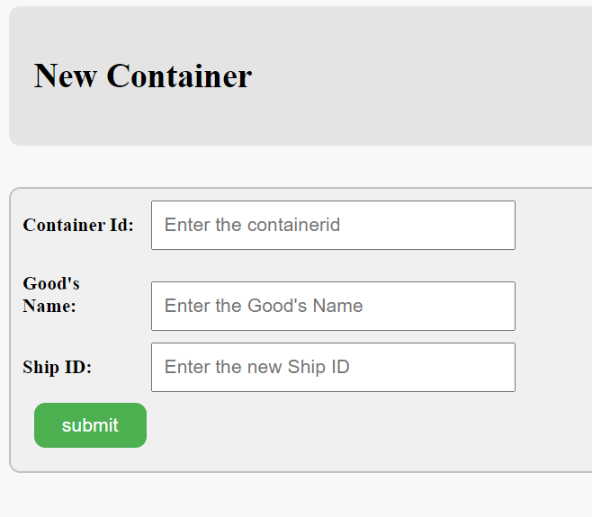

* + 1. Credit

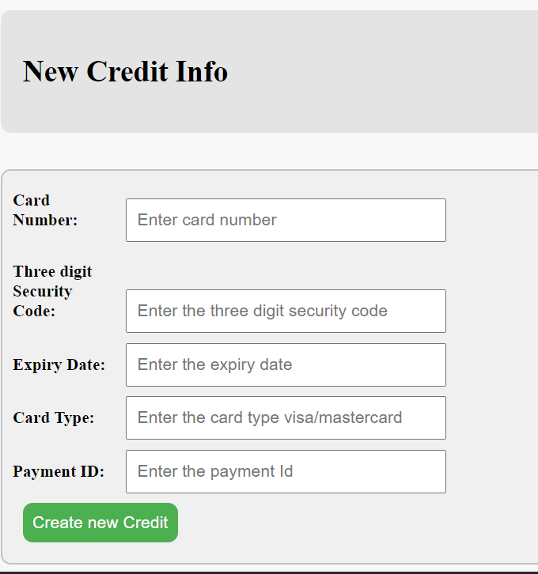

* 1. **Log In/Sign Up functionality functionality for:**
     1. Admin

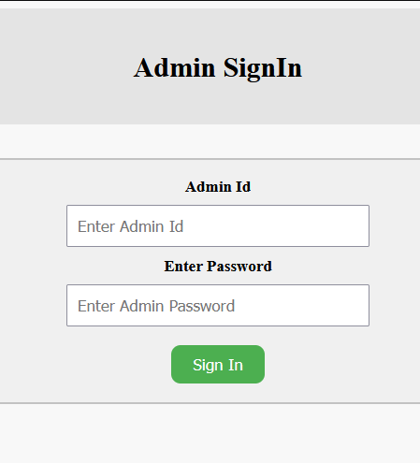

* + 1. Customer

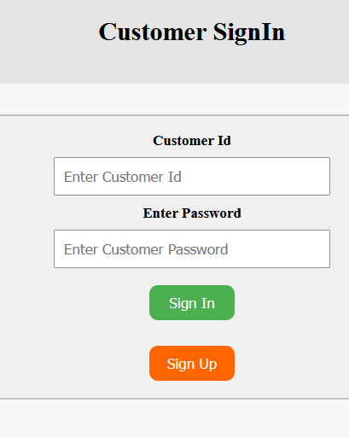

1. **Connectivity Screenshots:**

